Walk the Line Trapping Application User Support
The following instructions are based on a Samsung Galaxy S5 running Android version 5.0. Different devices and operating system versions may differ slightly, but the steps listed here should still apply.

Install the Walk the Line Application
If it is desired to install an instance of the walk the line application to update an existing instance on the device; then follow the process defined in the Uninstall the Walk the Line Application section of this guide first.
The Walk the Line application is installed on devices by first copying the Walk the Line application .apk file onto the device, while the application is in the development phase the name of this file may change from one release to another. This file maybe saved to an appropriate server of PC and copied to the device from there via USB/wireless link, copied from one device to another via a wireless link or downloaded directly to the device from the application support Google Drive account.
Access details for the application support Google drive account are:
Username: trapappandroid@gamil.com
Password: walktheline
To enable trapping data to be collected in a disconnected environment, after installing the application the user must install a data cache for one of more trapping areas which the user is granted access to through their logon credentials. This offline cache holds both the Topo basemaps and the trap data relevant to that area, after the application is installed it will sense that no cache yet exists and prompt the user to download one; this by default requires a WiFi connection (but can be changed to use mobile data in the app settings) and can be performed then or later.

- Once the application .apk file has been downloaded to the device, navigate to where it is saved on the device using a file navigation application (if one does not exist on the device one can be installed from the Play Store) and select the file.
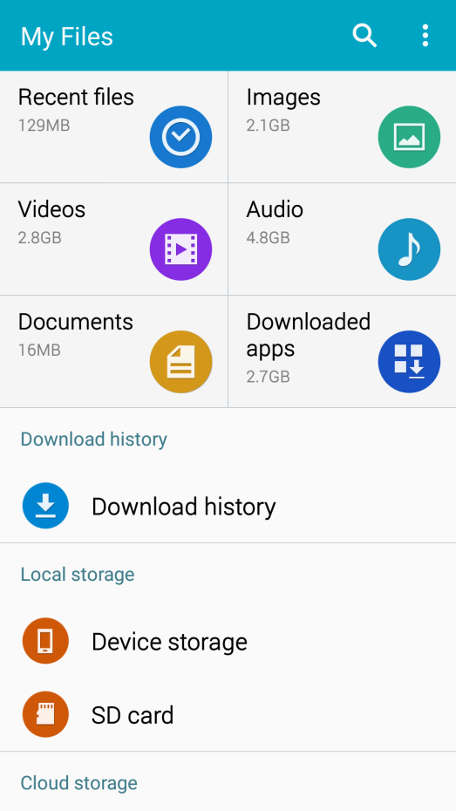
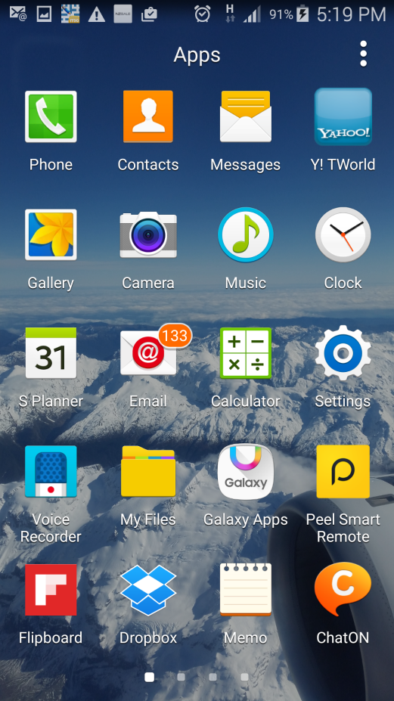

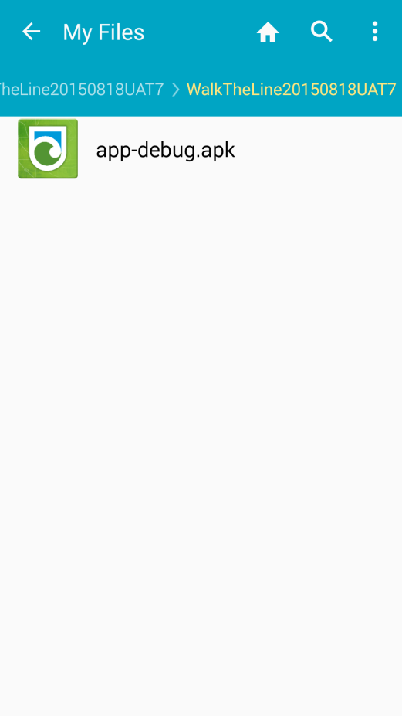

- By default most devices will be blocked from installing applications not sourced from the Play Store and will display the following message, select SETTINGS
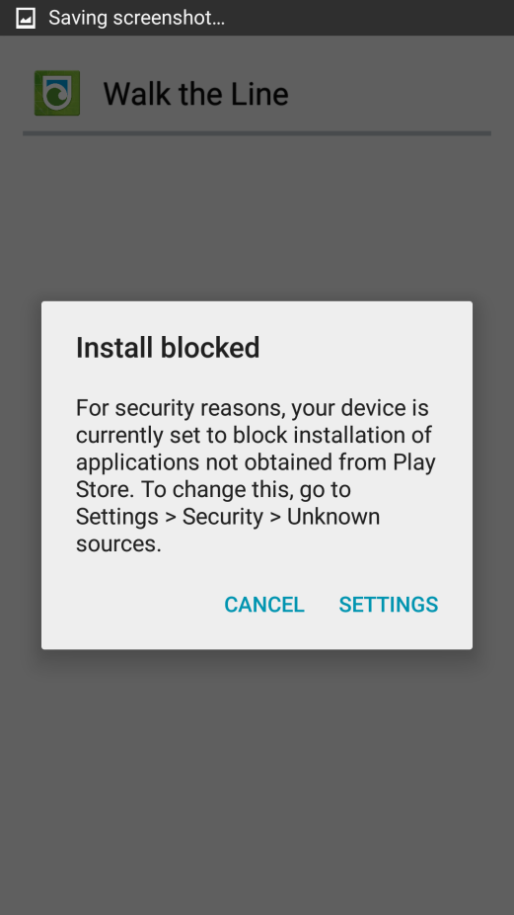

- Tick the Unknown sources box
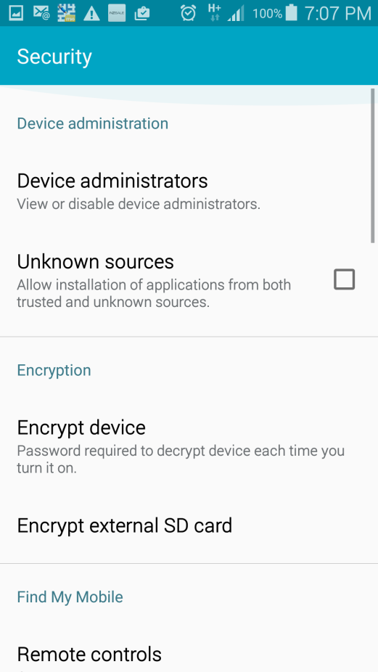

- Select OK in the Unknown sources window
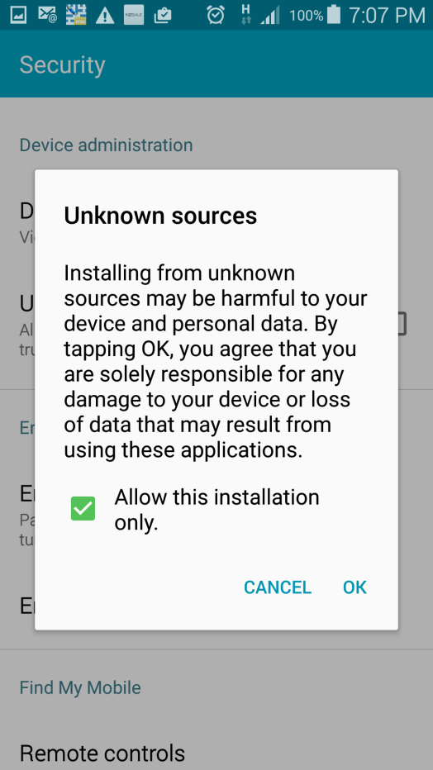

- Select INSTALL
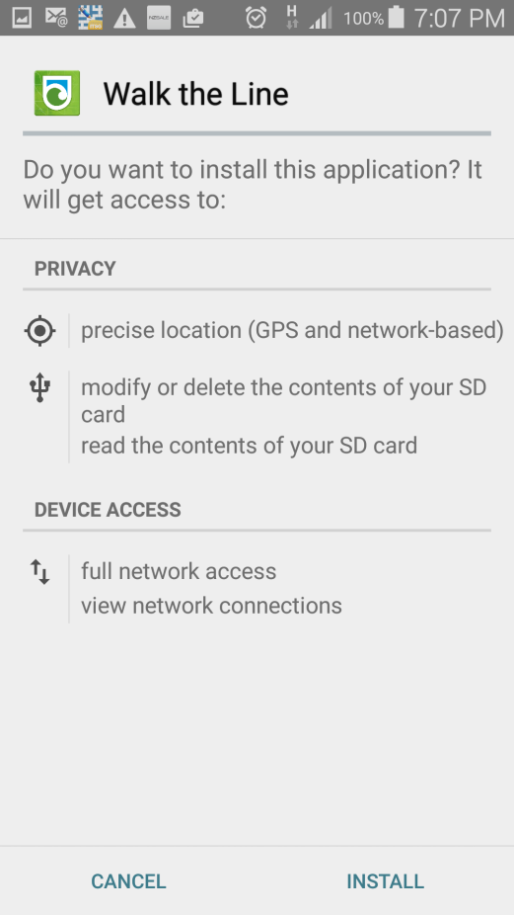

- Once the application has installed, if it is desired to download a data cache ensure the device has network connectivity and select OPEN and continue with the steps in this section, otherwise select DONE to perform this later
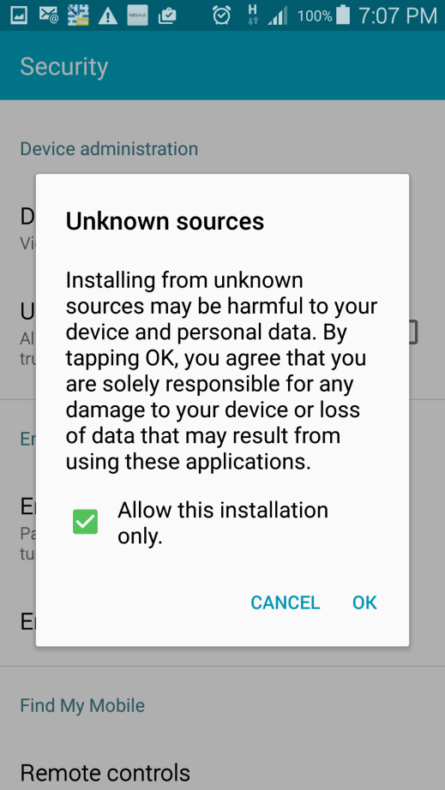

- Enter the site Login credentials and the name of the individual who will use the device, select Login
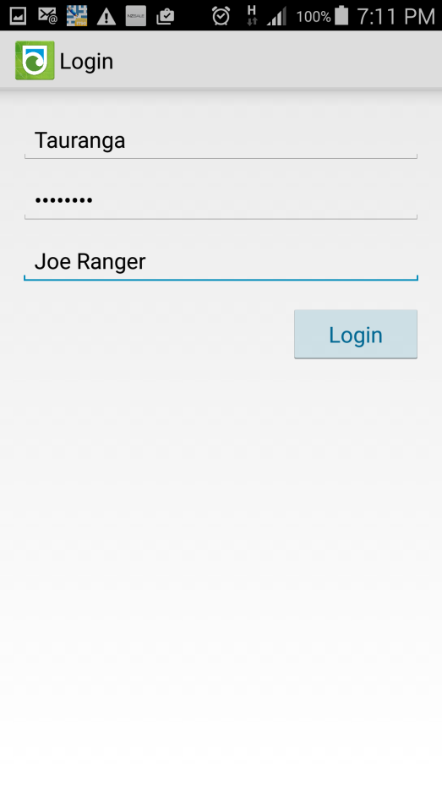

- If it is desired to download a data cache ensure the device has WiFi connectivity and select Yes and continue with the steps in this section, if it is desired to use a mobile data connection to download the data cache select No then refer to the sections on Settings to allow data transfer using a mobile data connection and Synch Data to download the data cache
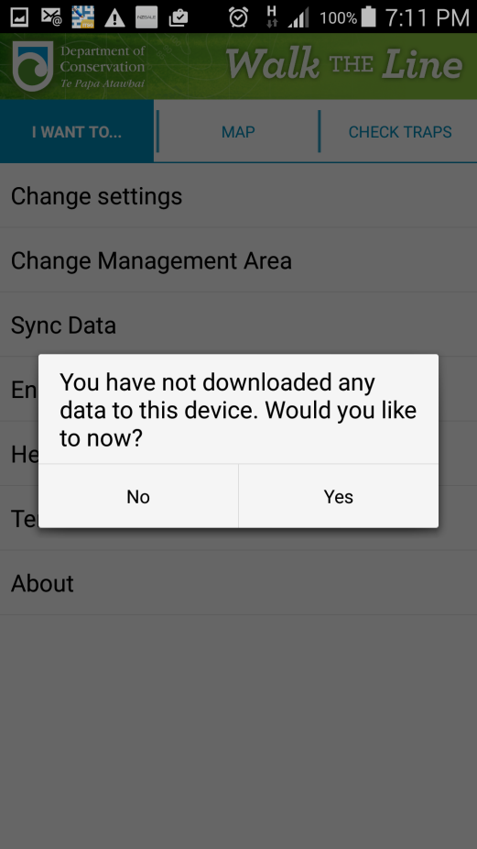

- Once the Please wait while data has loaded prompt completes, select the area to download the data cache for (if there is more than 1) from the dropdown and select Start Data Synch
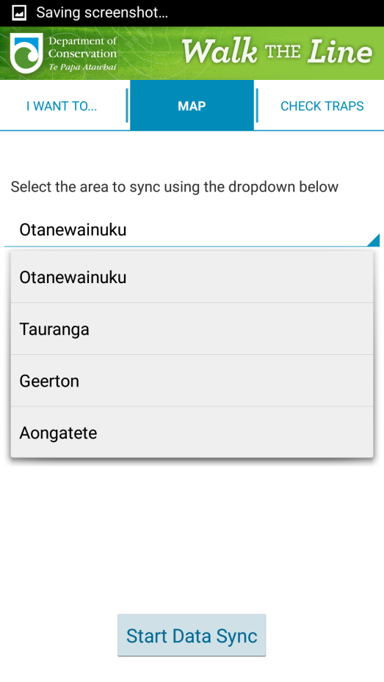
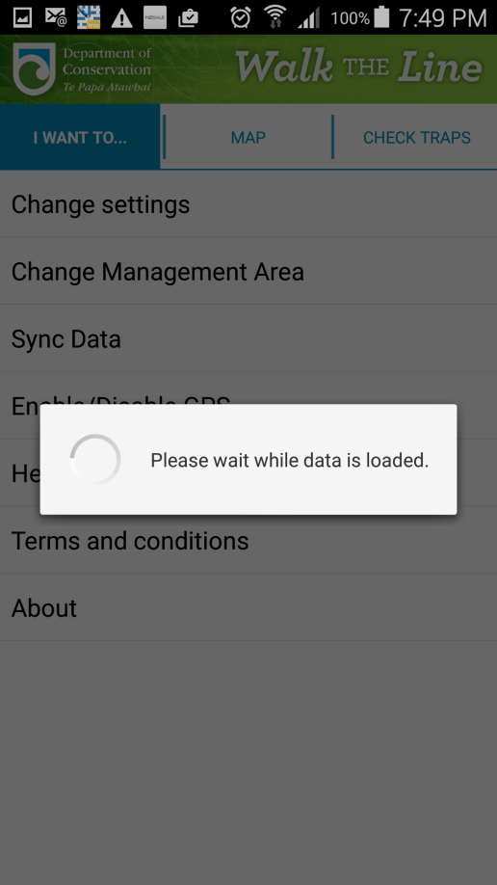

- Select OK
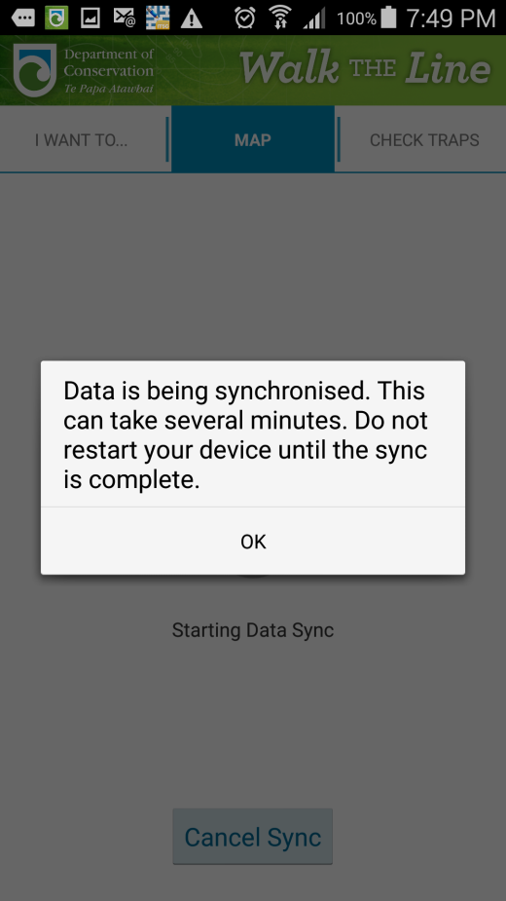

- Wait while the data synch is in progress, this can take some time when downloading the data cache for the first time, depending on the area of the trapping network being downloaded and the quality of the network connection; once this has successfully completed the device is ready to go and collect data for that trapping area. If it is desired to download additional trapping areas refer to the instructions in the Synch Data section
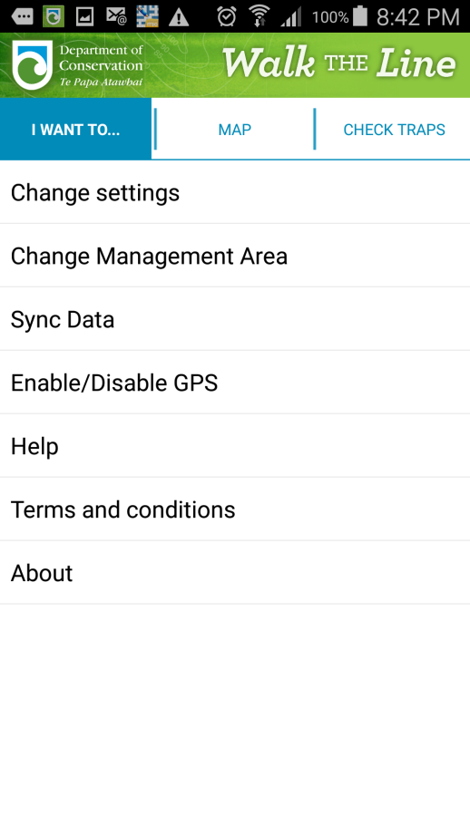
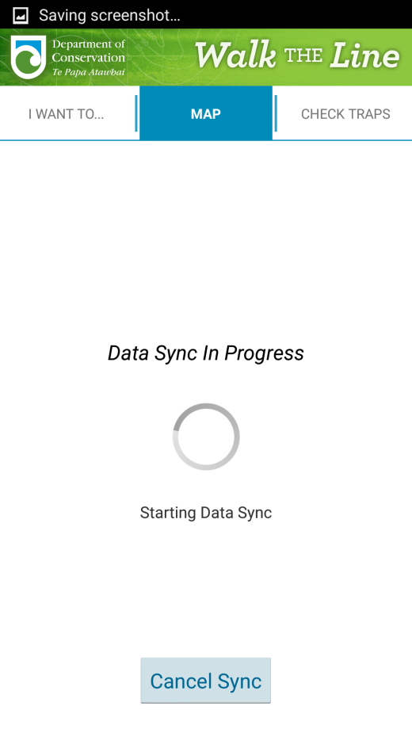

Uninstall the Walk the Line Application
- Ensure any outstanding collected data has been synchronised from the walk the Line application
- From the home screen select the Apps option
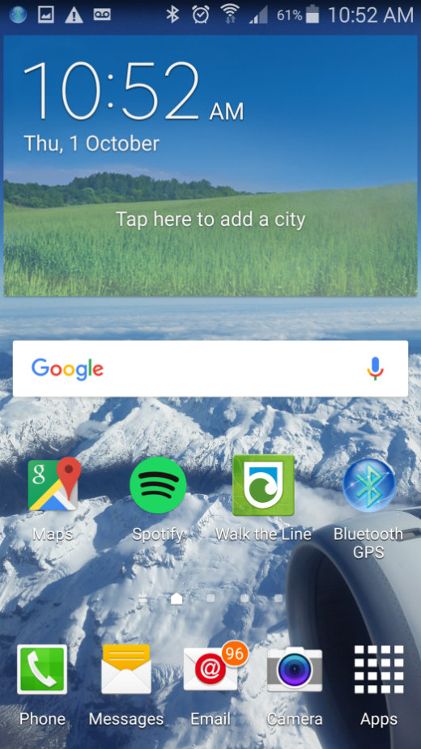

- Scroll to the screen with the Walk the Line tile and select the Menu option
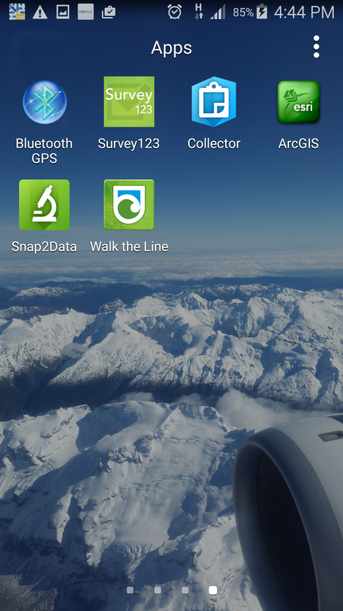

- From the menu select the Uninstall/disable apps option
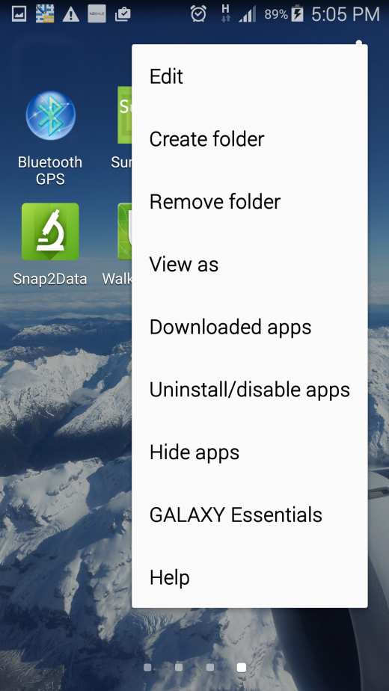

- Select the Walk the Line app tile to uninstall it
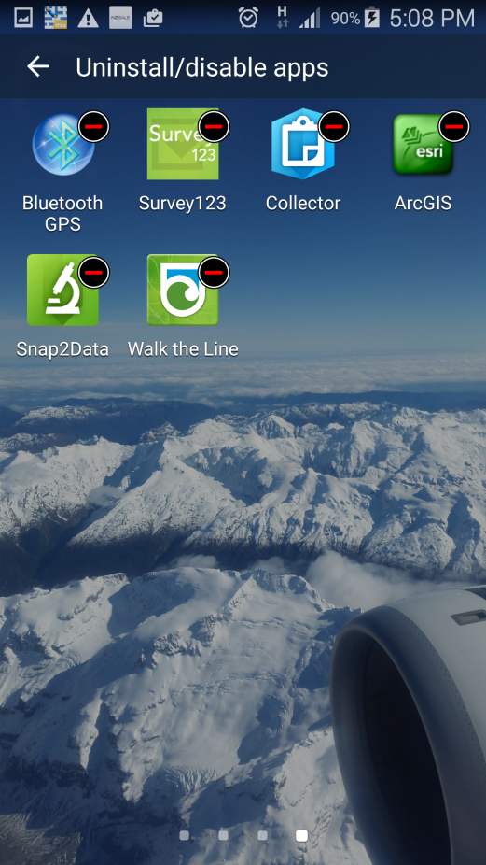

- Select UNINSTALL
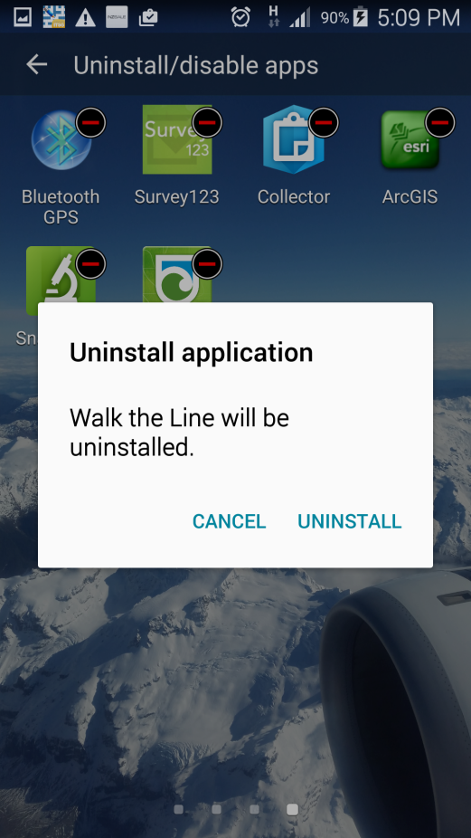

- Using a file navigation application (if one does not exist on the device one can be installed from the Play Store) navigate to the location on the docoffline folder (the root of the device storage)and delete it and all its contents
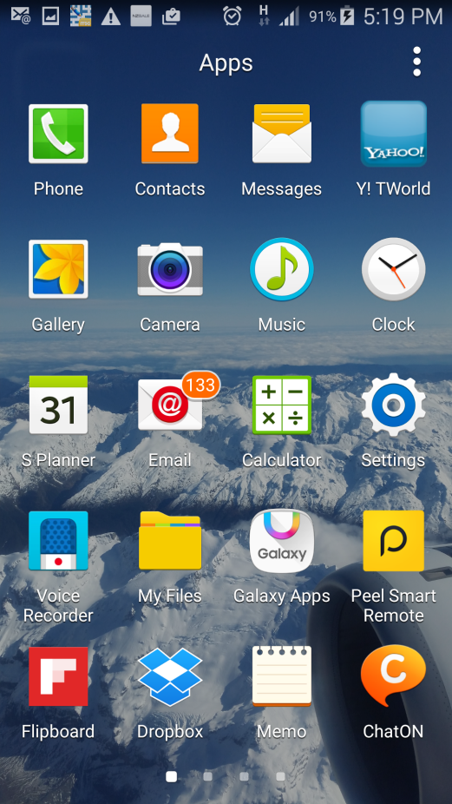
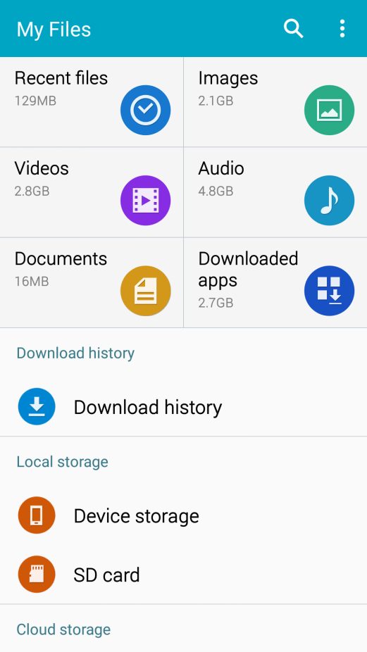

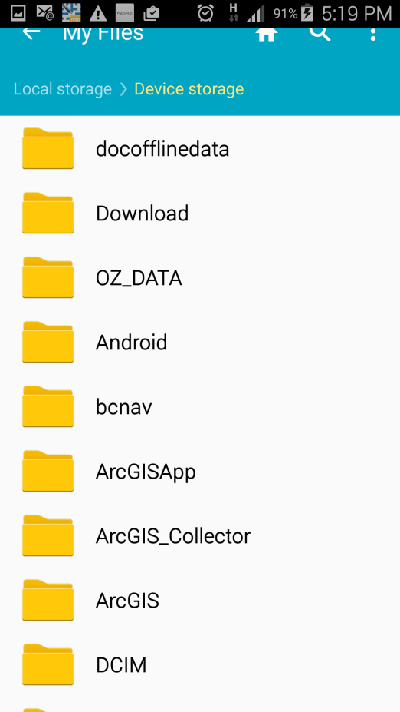
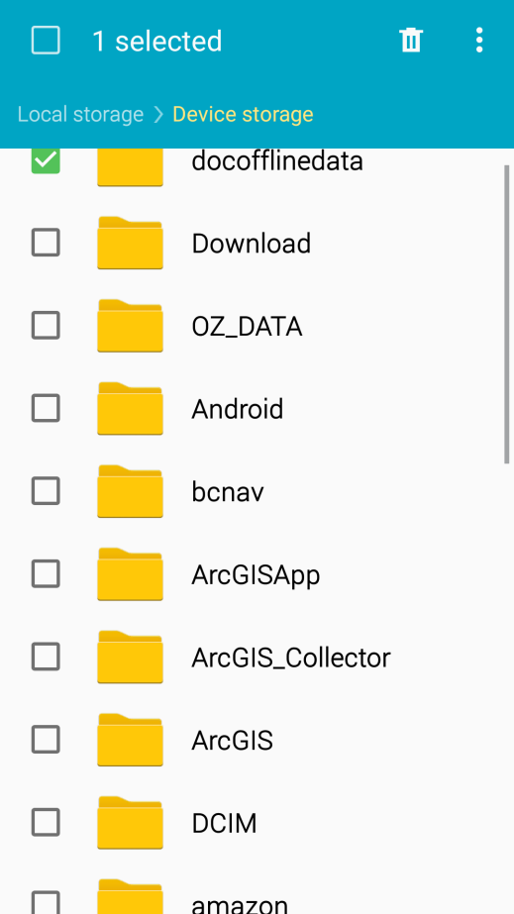

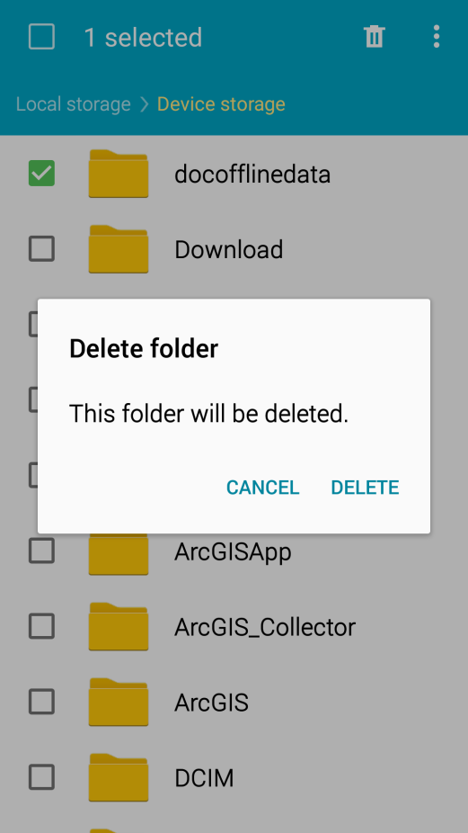

Connect a Bluetooth GPS to an Android Device with the Bluetooth GPS app.
- Turn on the Bluetooth GPS unit
- Ensure that the Walk the Line trapping application is closed
- Turn on the devices Bluetooth and ensure the GPS is disabled
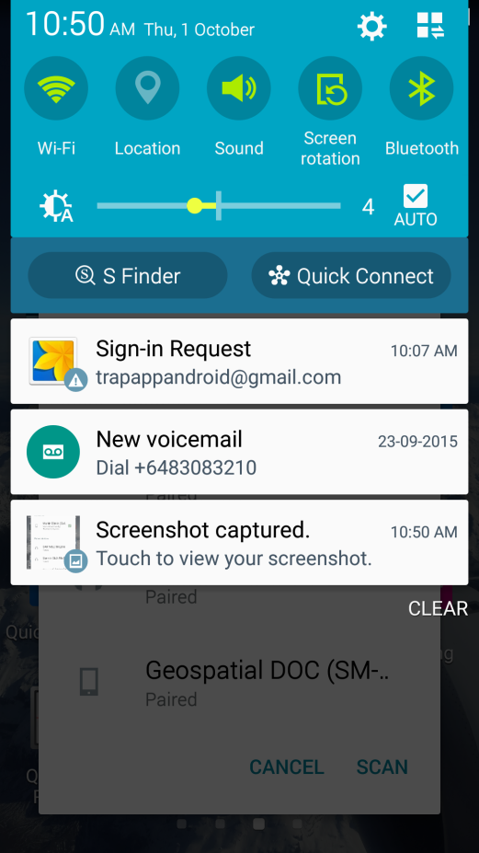

- Ensure that the Bluetooth GPS is listed as Paired on the Bluetooth paired devices list; it does not need to be connected. If the GPS unit is not listed on the Paired devices list, scroll down to see if it is listed under the Available devices list, if it is not listed there use SCAN to add it to the list; select the GPS unit from the Available devices list to pair it and add it to the paired devices list.
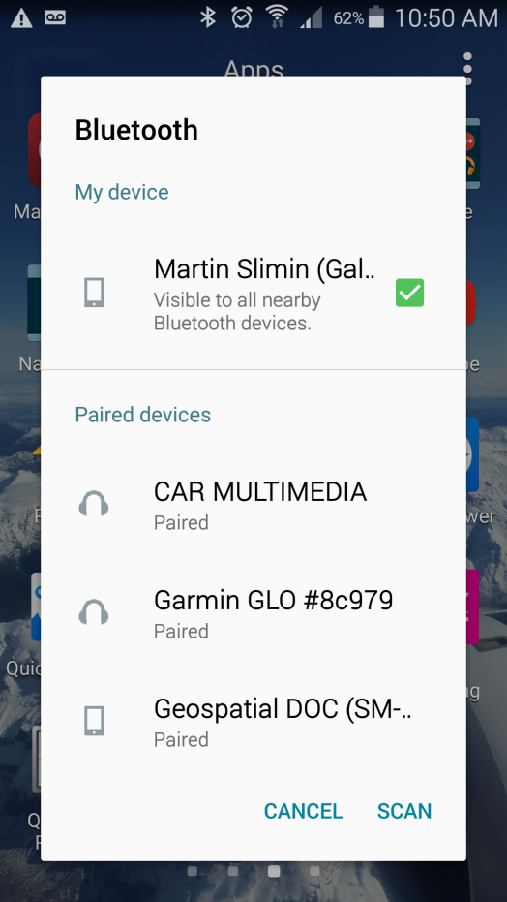

- Open the Bluetooth GPS app
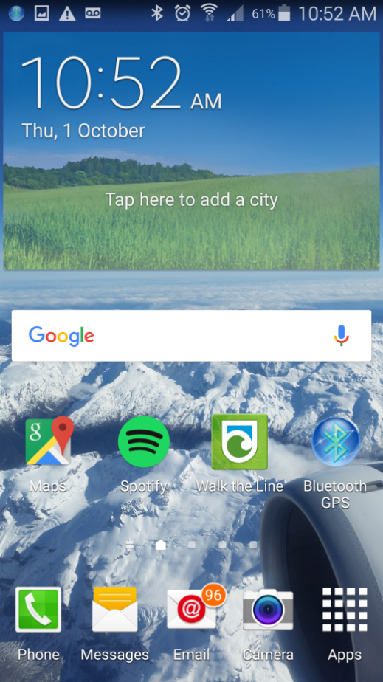

- Ensure the GPS unit is listed on the Bluetooth GPS app screen, select CONNECT and ensue Enable Mock GPS Provider is ticked
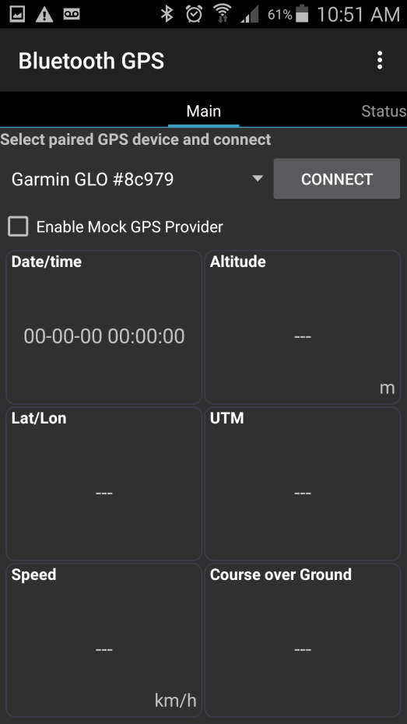

- Open the Walk the Line trapping app
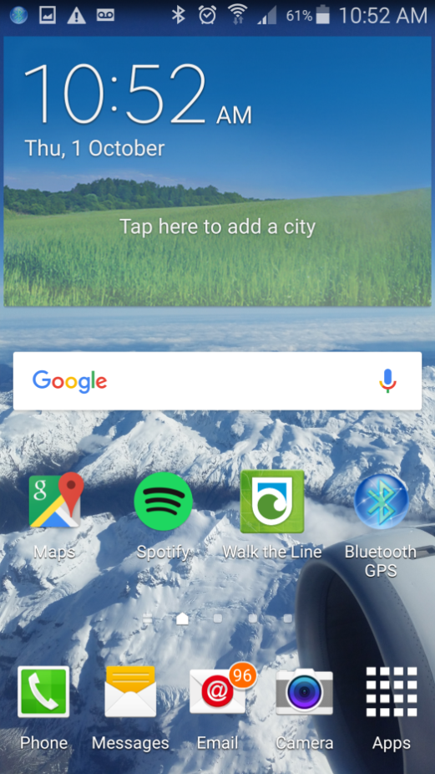

- Sign into the app, open the MAP screen and select the GPS icon
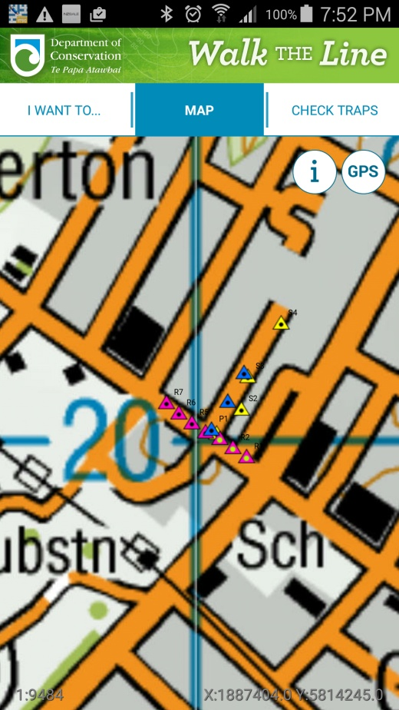

- Select Enable GPS
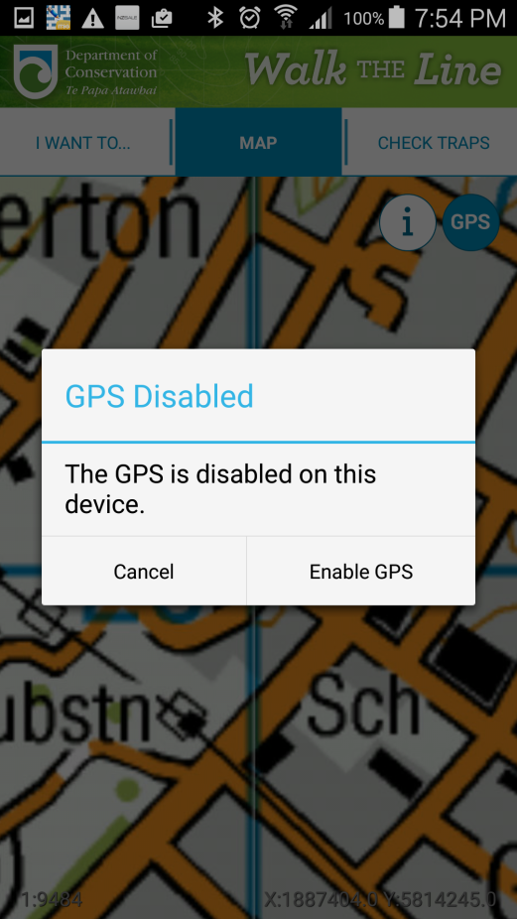

- Close the Location screen, DO NOT ENABLE LOCATION SERVICES
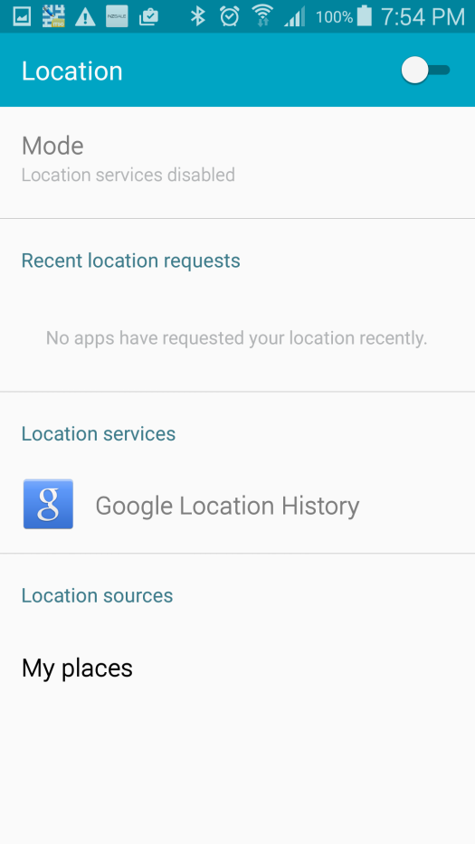

- The GPS location as provided by the GPS unit should now be available in the application

